Turn Your Vacations into Donations!
Alliance of Rounds Traditional and Square Dance
Now Has It’s Own Travel Website!
That Supports Your Dance Activity!

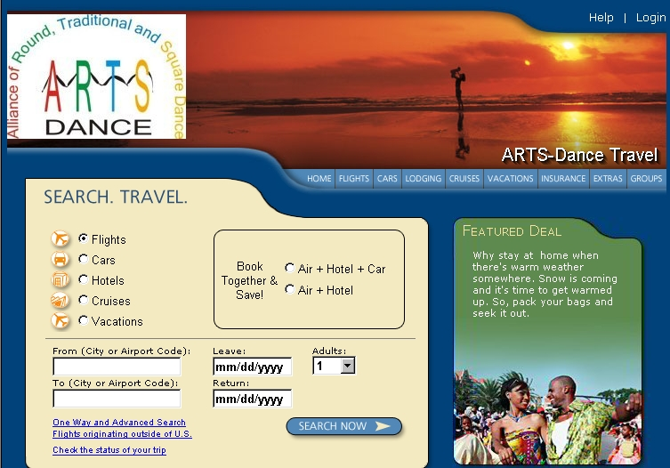
Book your dance, personal and business travel on our new travel website...

www.arts-dancetravel.com

Every time you do, ARTS
will receive a portion of the
travel commissions.

Receive the same low rates as those other travel websites and help generate $1,000’s for
ARTS-Dance

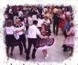


It’s that simple!

Just Log on To

www.arts-dancetravel.com

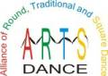
Each time you use our new travel website, ARTS the Alliance of Rounds Traditional and Square Dance will receive a portion of the travel commissions from the companies you use.

Great Rates On

Air • Hotels • Rental Cars • Cruises • Vacations

