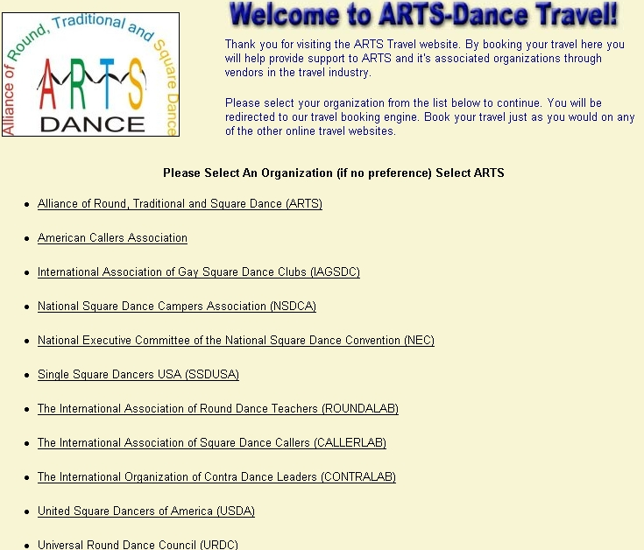
Turn Your Vacations Into Donations!
Traveling soon? Forget those other travel websites! Book your dance, personal and business travel on our new travel website below.

Get great travel rates and help fund the future of Dancing through ARTS!
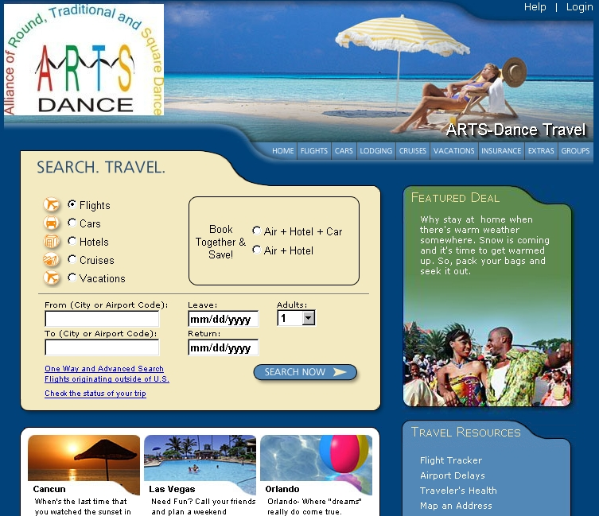
www.arts-dancetravel.com

Great Rates On
Air • Hotels • Rental Cars • Cruises • Vacations


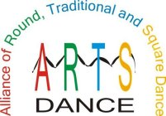
Each time you use our new travel website, ARTS the Alliance of Rounds Traditional and Square Dance. Will receive a portion of the travel commissions from the companies you use.

