Turn Your Vacations Into Donations!

Alliance of Round, Traditional and Square Dance
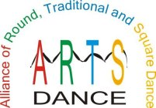
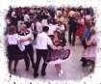
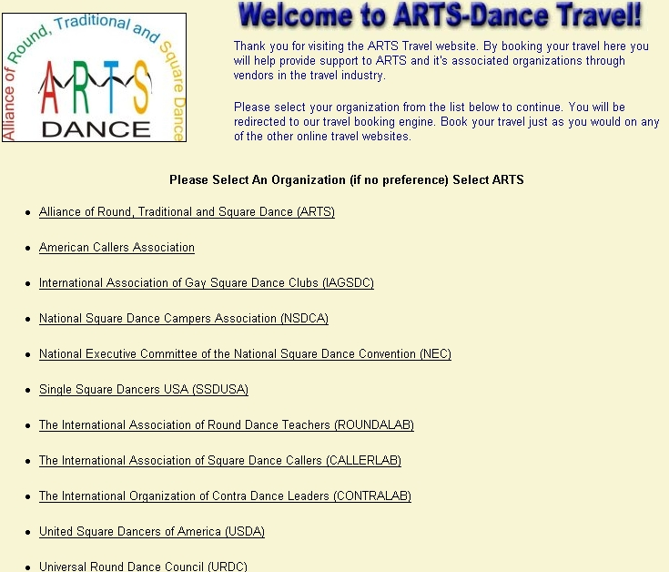
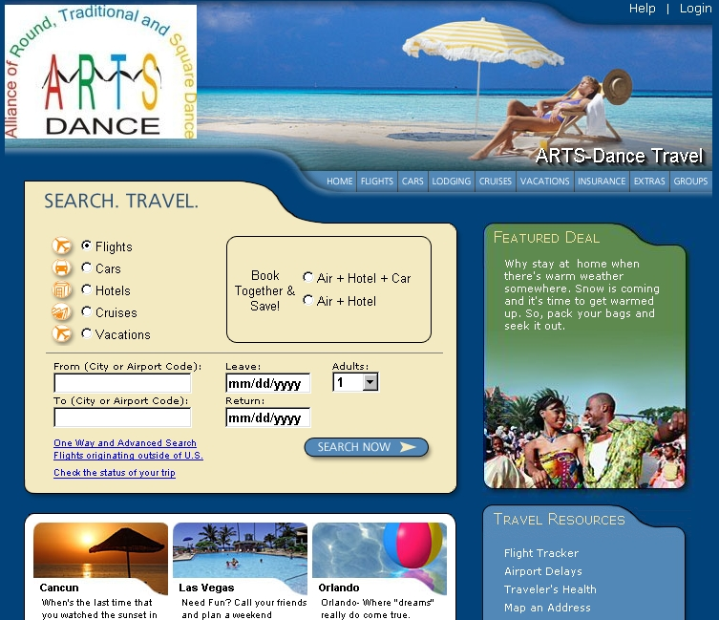Now Has It’s Own Travel Website!
Each time you use our new travel website, ARTS the Alliance of Rounds Traditional and Square Dance. Will receive a portion of the travel commissions from the companies you use.

www.arts-dancetravel.com
Traveling soon? Forget those other travel websites! Book your dance, personal and business travel on our new travel website below.

Get great travel rates and help fund the future of Dancing through ARTS!
Great Rates On
Air • Hotels • Rental Cars • Cruises • Vacations

