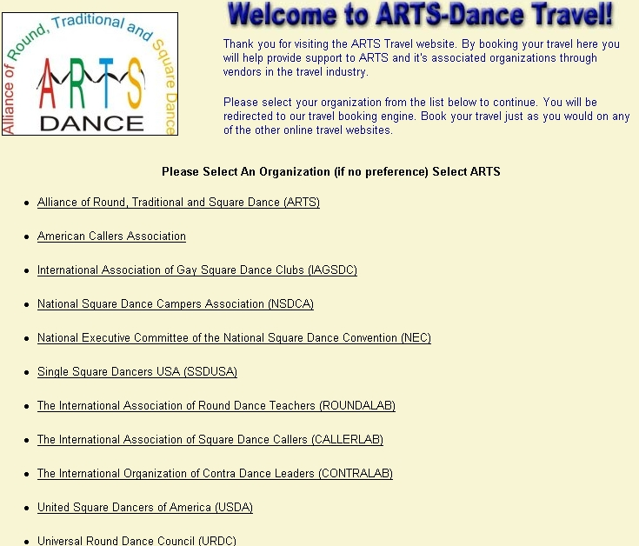
Turn Your Vacations Into Donations!
www.arts-dancetravel.com

Alliance of Round, Traditional and Square Dance
Traveling soon? Forget those other travel
websites! Book your dance, personal and
business travel on our new travel website.
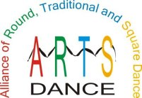Get great travel rates and help fund
the future of Dancing
through ARTS!
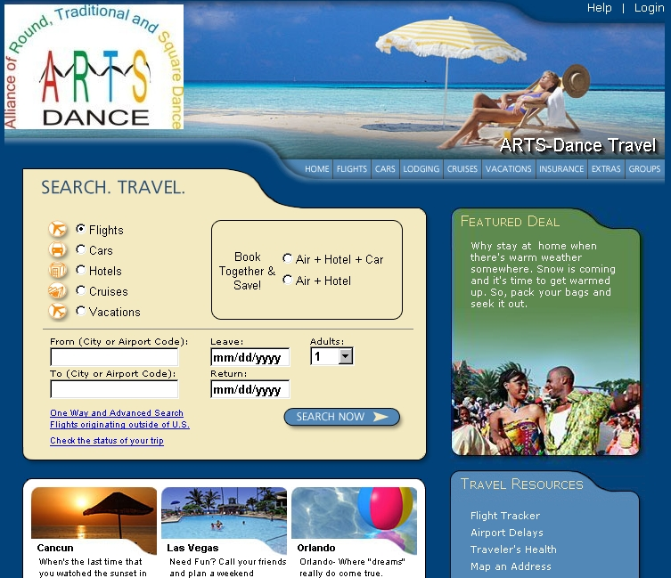 Now Has It’s Own Travel Website!
Great Rates On
Air • Hotels • Rental Cars • Cruises • Vacations

