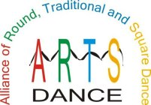
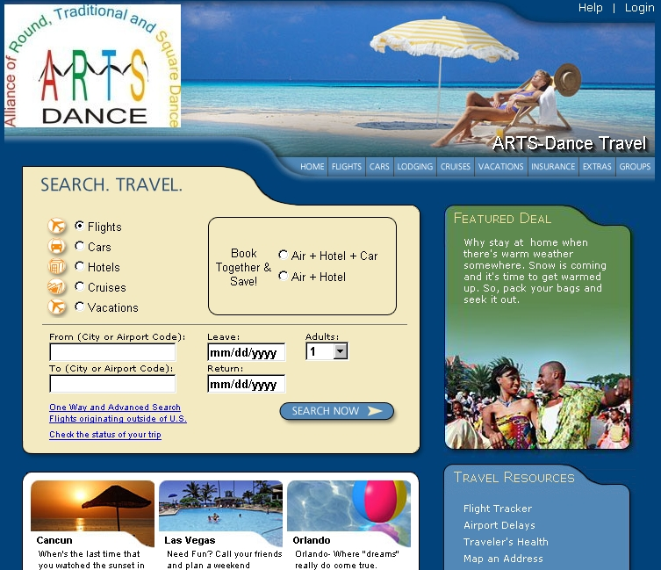
Turn Your Vacations Into Donations!
Traveling soon? Forget those other travel
websites! Book your personal and
business travel on our new travel website
below. Get great travel rates and help
fund ARTS!
www.arts-dancetravel.com
Great Rates On
Air • Hotels • Rental Cars •
Cruises • Vacations
Each time you use our new travel website, ARTS the Alliance of Rounds Traditional and Square Dance. Will receive a portion of the travel commissions from the companies you use.

