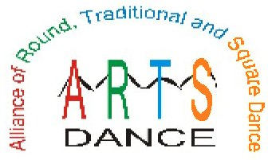
Dance Across America
ARTS Annual Benefit Dance
Join Dancers, Callers & Cuers
Across America for this Special Dance
by helping to promote our activity by donating the proceeds from this dance to ARTS-Dance to help in the preservation and perpetuation of our multi-faceted dance activity.

Please Join

When:

Where:

Time:

Callers:
Cuers:
Door Donation: $ Per Person
(All Proceeds will be donated to ARTS-Dance)

The ARTS-Dance is registered with the IRS as a 501(c) (3) corporation and all donations to the Foundation are tax deductible.

For Additional Information look at the web site www.arts-dance.org

