ASK ARTS # 21
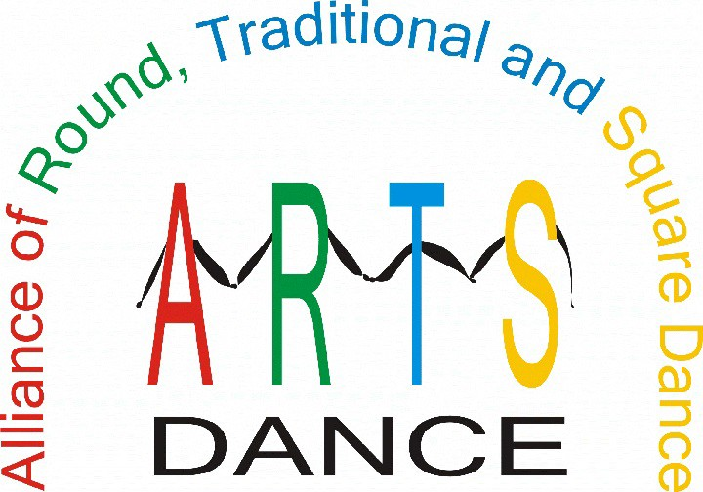

DANCE ACROSS AMERICA
ARTS Benefit Dances
By Del Reed (November 06, 2019)

Dear ARTS,

I remember our square dance association hosting a dance to raise money for The ARTS several years ago. The dance was one of many held all across the country. As a result, we donated nearly $1,000.00 to help fund The ARTS activities including financial grants, support of the Live Lively Re-Image Project, and other important activities.

I recently looked at the ARTS-DANCE website (www.ARTS-DANCE.org) and clicked on the link to “DANCE ACROSS AMERICA - ARTS Benefit Dances.” I am interested to learn if there are more benefit dances being planned and if so, how will it work and how can we get involved.

Curious in California Dear Curious,
The “Dance Across America” dances are part of a nationwide effort to raise money for The ARTS. The plan is to encourage clubs and associations to host benefit dances on the same day, Saturday, February 29, 2020.

State and regional organizations, as well as local clubs, and individuals are asked to plan and sponsor dances to be held simultaneously all around the country. Hopefully, organizations will donate use of a dance hall and callers/cuers will donate their fees for the event, with all proceeds going to The ARTS for nationwide promotional activities.

In addition, these benefit dances will provide opportunities for local publicity, which raises awareness of the presence of the dance activity in local areas.

Please, join us in our fund raising efforts to help us finance the cost of a nationwide publicity campaign! Support or organize a “Dance Across America” event, list your dance on the ARTS website and report the number of attendees so we can total the number of dancers for that day. Downloadable promotional materials are available at www.arts- dance.com.

Other fund raising projects currently underway include:

- “Add A Buck Program,” where dances/festivals ask participants for a voluntary donation of $1/pp

- Shopping on the AmazonSmile website which generates income to The ARTS when you log into AmazonSmile and purchase items just as you always have.

- Individual Membership as a way to support The ARTS.

Please direct any questions for ASK ARTS to Del Reed at: www.askarts@arts-dance.org

(NEWS FLASH - 2019 - 2020 ARTS Officers Have Been Elected. Congratulations to the following: Butch & Ampie Hayes, Chairman; Erin Byars, Vice Chairman; Edythe Weber, Treasurer, and Jim & Judy Taylor, Secretary)

19/11/06 02:54:58 PM
C:\Users\Jerry\Documents\Jerry Files\ARTS Information\Ask ARTS\ASK ARTS #21 (Approved) (19-11-06) (Dance America).wpd

