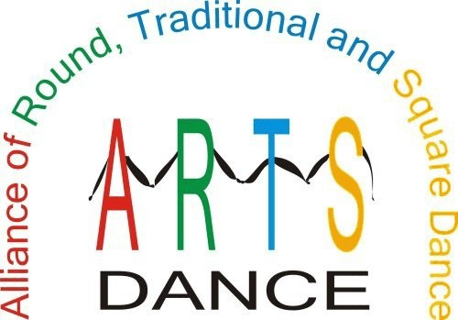

Dear ARTS,
ASK ARTS #19
(September 15, 2017)

I recently saw flyers for travel to the 67th NSDC in Kansas City, MO in June 2017. I am planning to fly from the Florida to Kansas City. I have used other travel web sites such as Priceline in the past. I understand the ARTS Travel site is just as cost effective and a they make a donation to The ARTS. Is this true?
Traveler from Tallahassee

Dear Traveler,

The ARTS Travel web site

The ARTS Travel web site (www.arts-dancetravel.com) is one of the most exciting things yet for ARTS. We have partnered with YTB International, Inc, a publicly traded travel management company. ARTS has a personalized travel web site with the same features and prices as other online booking agents such as Priceline, Expedia, and Travelocity.

YTB created, secured, and maintains the web site at no cost to ARTS. Our role is to publicize the site and encourage dancers and others to use the site. You do not have to be an ARTS member to participate. The more people who know about the web site, the more traffic it will get, eventually generating funds 24/7.

Here's how it works; travelers go online to www.arts-dancetravel.com to book personal, dance, and business travel at competitive online rates. ARTS receives a generous portion of the generated commission in return. This means you support ARTS in a very meaningful way each time you book airfare, cruises, auto rental, and hotel stays.

Travel is the largest industry in the world. Past surveys have shown that dancers are great travelers. Give it a try! It costs nothing to check it out and see the same low rates as other providers offer. This plan can help ARTS accumulate the money required to support our promotion and marketing efforts. Links to the travel web site are also at www.arts-dance.com

ARTS-DANCE

Please direct any questions for ASK ARTS to Del Reed at 321-633-1306, or e-mail at askarts@arts-dance.org.

9/15/2017 11:3106A
C:\Users\Jerry\Documents\Jerry Files\ARTS Information\Ask ARTS\ASK ARTS #19 (17-09-01)(ARTS Travel).wpd

