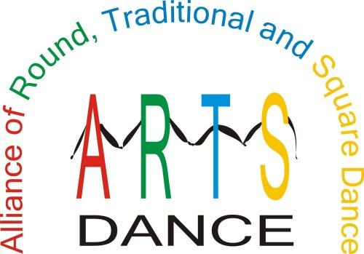
PROMOTE & PRESERVE OUR DANCE ACTIVITY

ARTS-DANCE ACCOMPLISHMENTS

- Cooperation between national organizations to increase the number of dancers in the activity
- Grant to the California Square Dance Council to create a notebook and CD for teachers to use in the schools to teach youth to square dance
- Toll-free number – 866-445-ARTS(2787)
- Magnetic signs with the toll-free number on them
Add-A-Buck to your entrance fee and donate it
to the ARTS.
- Travel website that donates a portion of the commissions to the ARTS
- Lapel pins
- What Is ARTS brochure and membership application
- Participation in the Education Program at the National Square Dance Convention®
- Table in the Showcase of Ideas at the National Square Dance Convention®
HOW YOUR DONATIONS WILL HELP

- Provide educational materials
- Fund market research
- Develop an advertising campaign
- Develop educational programs
- Develop advertising materials
- Preserve historical materials
- Matching funds for grants

THE ARTS Dance FOUNDATION is registered with the IRS as a 501(c)(3) corporation and all donations to the Foundation are tax deductible.

