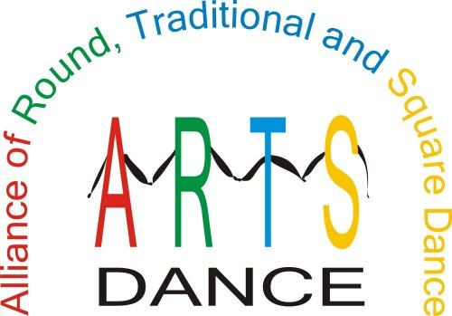

ARTS-DANCE ACCOMPLISHMENTS
PROMOTE & PRESERVE OUR
DANCE ACTIVITY

- Cooperation between national organizations to increase the number of dancers in the activity
- Surveys at several National Square Dance Conventions® to assist in market research
- Grant to the California Square Dance Council to create a notebook and CD for teachers to use in the schools to teach youth to square dance
- Toll-free number – 866-445-ARTS(2787)
- Magnetic signs with the toll-free number on them
- Travel website that donates a portion of the commissions to the ARTS
- Lapel pins
- What Is ARTS brochure and membership application
- Participation in the Education Program at the National Square Dance Convention®
- Table in the Showcase of Ideas at the National Square Dance Convention®

THE ARTS Dance FOUNDATION is registered with the IRS as a 501(c)(3) corporation and all donations to the Foundation are tax deductible.

