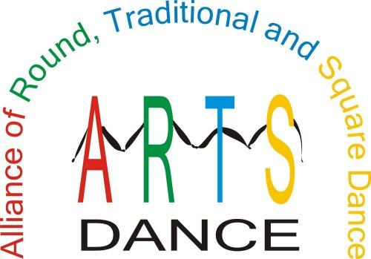

HOW YOUR DONATIONS WILL HELP
PROMOTE & PRESERVE OUR DANCE ACTIVITY

- PROVIDE EDUCATIONAL MATERIALS

- FUND MARKET RESEARCH

- DEVELOP AN ADVERTISING CAMPAIGN

- DEVELOP EDUCATIONAL PROGRAMS

- DEVELOP ADVERTISING MATERIALS

- PRESERVE HISTORICAL MATERIALS

- MATCHING FUNDS FOR GRANTS

THE ARTS Dance FOUNDATION is registered with the IRS as a 501(c)(3) corporation and all donations to the Foundation are tax deductible.

