This note serves as your receipt for tax purposes related to the calendar year ___________.  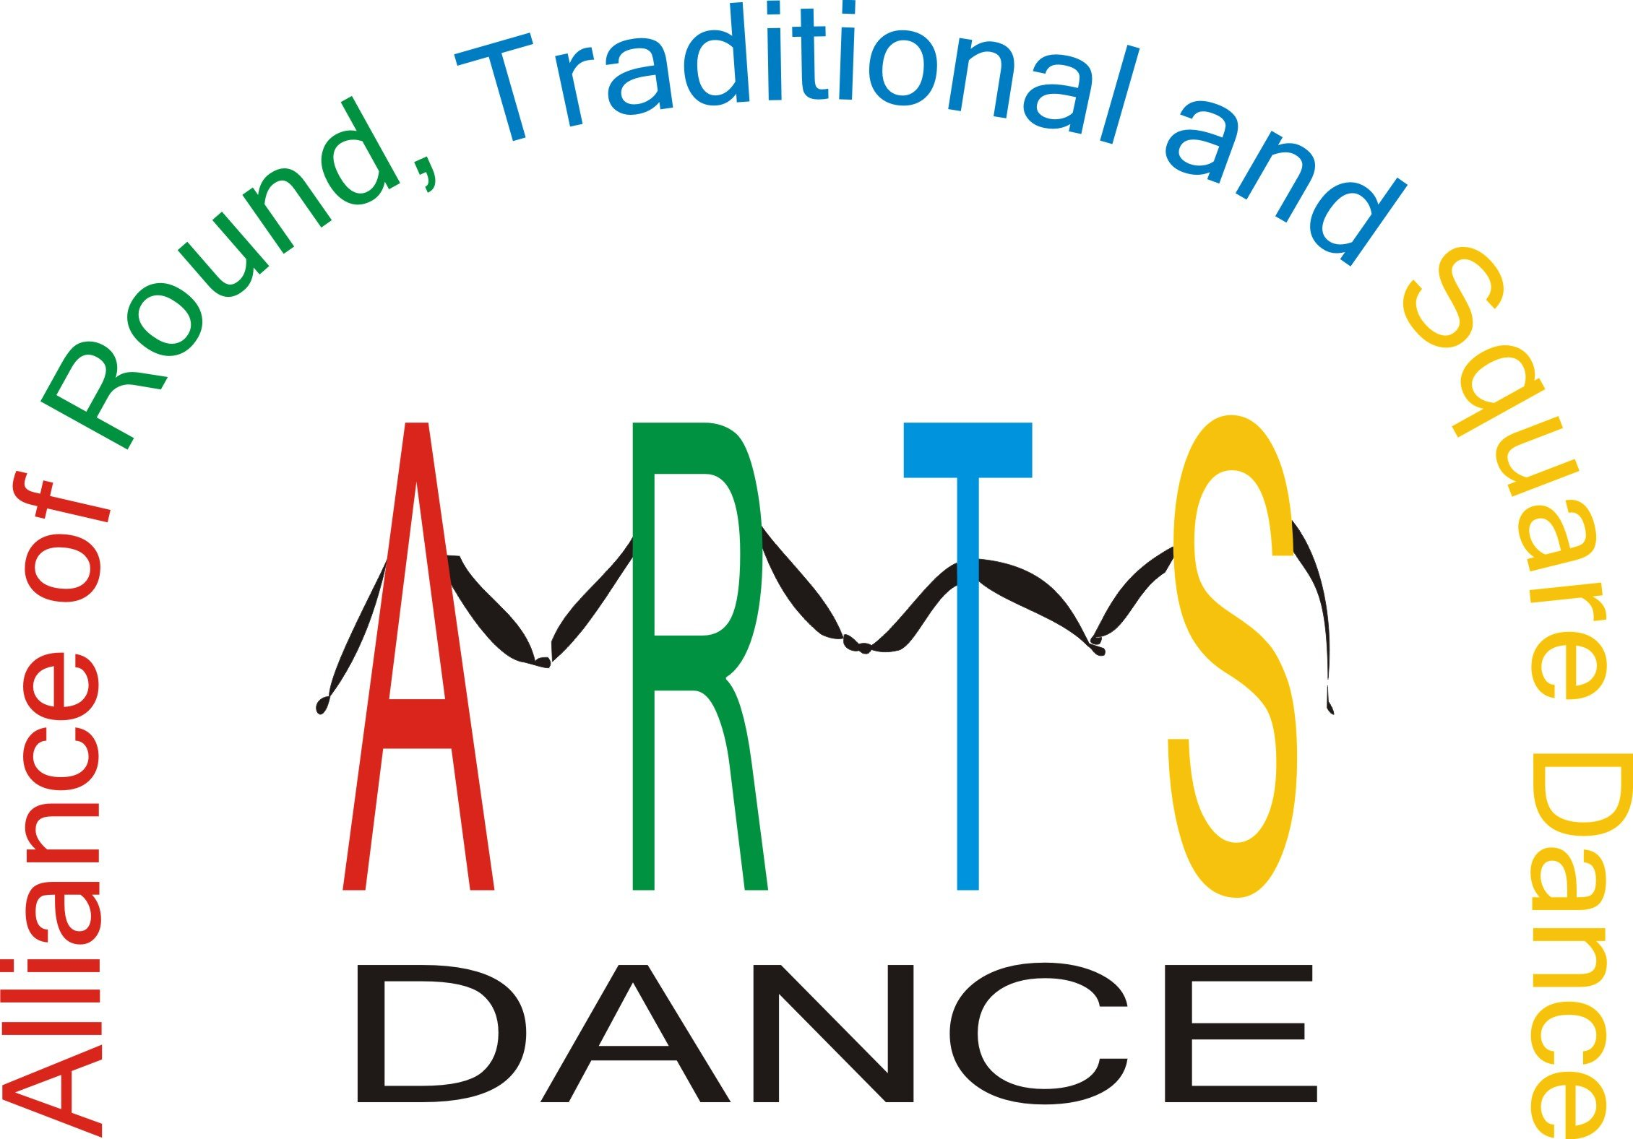  The ARTS-DANCE FOUNDATION certifies no goods or services were granted in connection with this contribution of $______________.  Date __________________________________ | This note serves as your receipt for tax purposes related to the calendar year __________.  The ARTS-DANCE FOUNDATION certifies no goods or services were granted in connection with this contribution of $_____________.  Date __________________________________
This note serves as your receipt for tax purposes related to the calendar year ___________.  The ARTS-DANCE FOUNDATION certifies no goods or services were granted in connection with this contribution of $______________.  Date __________________________________ | This note serves as your receipt for tax purposes related to the calendar year __________.  The ARTS-DANCE FOUNDATION certifies no goods or services were granted in connection with this contribution of $_____________.  Date __________________________________
This note serves as your receipt for tax purposes related to the calendar year ___________.  The ARTS-DANCE FOUNDATION certifies no goods or services were granted in connection with this contribution of $______________.  Date __________________________________ | This note serves as your receipt for tax purposes related to the calendar year __________.  The ARTS-DANCE FOUNDATION certifies no goods or services were granted in connection with this contribution of $_____________.  Date __________________________________
This note serves as your receipt for tax purposes related to the calendar year ___________.  The ARTS-DANCE FOUNDATION certifies no goods or services were granted in connection with this contribution of $______________.  Date __________________________________ | This note serves as your receipt for tax purposes related to the calendar year __________.  The ARTS-DANCE FOUNDATION certifies no goods or services were granted in connection with this contribution of $_____________.  Date __________________________________
This note serves as your receipt for tax purposes related to the calendar year ___________.  The ARTS-DANCE FOUNDATION certifies no goods or services were granted in connection with this contribution of $______________.  Date __________________________________ | This note serves as your receipt for tax purposes related to the calendar year __________.  The ARTS-DANCE FOUNDATION certifies no goods or services were granted in connection with this contribution of $_____________.  Date __________________________________

