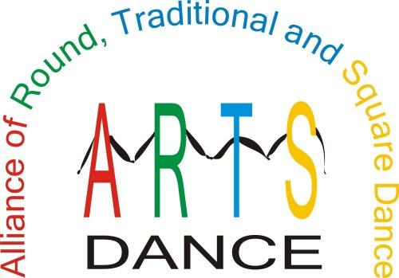

ADD-A-BUCK DONATION REMITTANCE FORM

DATE” _________________________________

NAME OF DANCE:________________________________________________

If you wish, you may list individuals who donate MORE than $1 or just the total number of donors and total amount.
Name | Amount donated
Totals

Name of Organization & contact information:
Organization Name:
Street Address:
City: | State (Providence) | Zip
Contact Name: | Contact Phone:
Contact E-mail:

PLEASE MAKE AND KEEP A COPY FOR YOUR RECORDS
Return this form and your donations to:
ARTS Dance Foundation
Treasurer, Edythe Weber
1316 Middlebrook Dr
Liberty, MO 64068-1941

