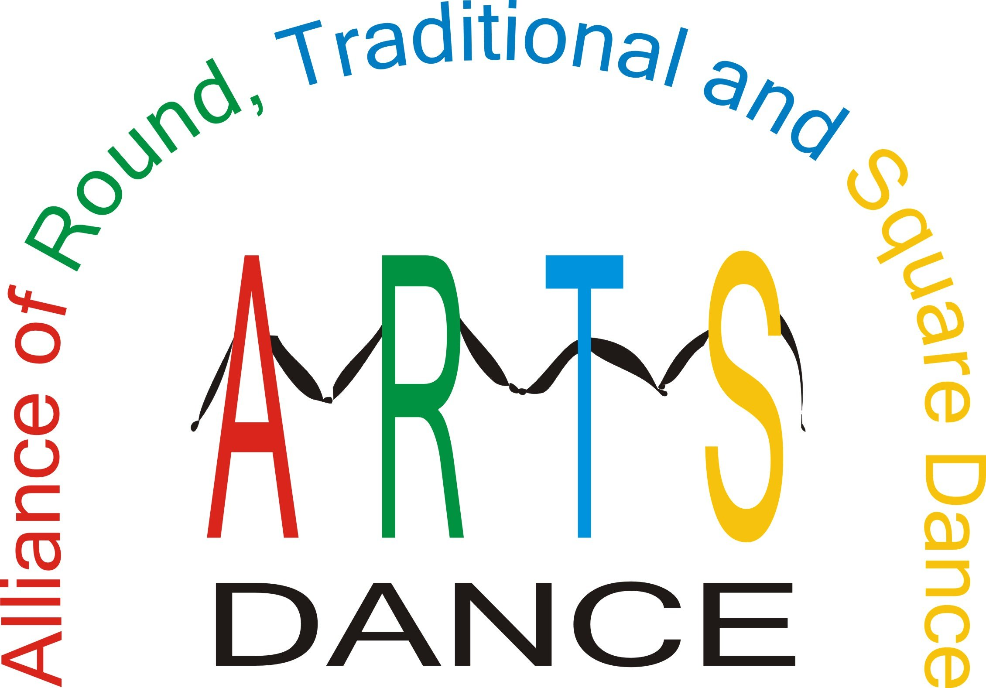

Alliance of Round, Traditional and Square Dance
Add-A-Buck
Program
Fund Raising Project

ARTS-Dance
Add-A-Buck Program

TABLE OF CONTENTS

- Program Overview
- Sample Wording
- Sample Flyer #1
- Table Poster #1
- Table Poster #2
- Table Poster #3
- Table Poster #4
- Donating Organization Treasurer Responsibilities
- Multiple donation sheet (can be copied and given to donors)
- Remittance Form to Report Donations

All these documents are also available on the web at http://www.arts-dance.org/

“Add a Buck” Program Overview
Purpose:
To get organizations holding Festivals and Conventions to voluntarily add and collect a small additional amount, where the dancers agree to do so, for donation to the ARTS Dance Foundation

Implementation:
This kit provides you with instructions, resources, examples of wording, materials for advertising, remittance instructions and gratitude.

Target:
Especially Festivals and Conventions, any dance events that are willing to “Add-A-Buck”.
Success assumptions
There will be an assumption that this will only work where organizers are aware and support the ARTS-Dance Foundation, its work, and plans. While the kits will include a brief overview of the ARTS Dance Foundation, it will be important to realize that the ARTS Dance Foundation needs much more exposure.
Brochures, annual reports and other information explaining the ARTS mission, goals and accomplishments are available upon request or can be printed from the ARTS website at www.arts-dance.org.
SAMPLE WORDING FOR FLYERS, TABLE POSTERS

The ARTS recognizes the reference to “Dancing’s Future” may not be appropriate in all situations. Square dancing, contra, clogging, round dance, or any form of dance can be substituted for the word “dancing” in any of these situations.

(Add to your dance flyer)

ADD A DOLLAR FOR DANCING’S FUTURE!
YOU MAY VOLUNTARILY ADD AN EXTRA DOLLAR OR MORE TO YOUR ADMISSION PRICE. ANY AMOUNT YOU ADD WILL BE SENT AS A DONATION TO THE ARTS Dance FOUNDATION

Dollars for Dancing: Add a Buck for Dancing’s Future
Donate a Dollar for Dancing’s Future

(Add to your dance registration form)
ADD A DOLLAR FOR DANCING’S FUTURE. An
Additional $______ is enclosed as a voluntary tax-deductible
donation to the ARTS Dance Foundation

(Add to your table poster)

THE ARTS Dance FOUNDATION is registered with the IRS as a 501(C)(3) corporation and all donations to the Foundation are tax deductible.

ANNUAL CHRISTMAS SEASON
SING – A – LONG
FRIDAY, DECEMBER 27TH, 2005
8:00 PM – 10:30PM
FEATURING

GOOD CALLER & GREAT CUER

NEW LOCATION
******DANCE HALL COMMUNITY CENTER******

306 PARKSIDE DR
YOUR TOWN, YOUR STATE

$10.00 PER COUPLE AT THE DOOR
PLUS LEVEL SQUARES - LIMITED TO 20 SQUARES
ADD A DOLLAR FOR DANCING’S FUTURE!
YOU MAY VOLUNTARILY ADD AN EXTRA DOLLAR
OR MORE TO YOUR ADMISSION PRICE. ANY AMOUNT YOU
ADD WILL BE SENT AS A DONATION TO THE ARTS Dance FOUNDATION

Please mail your check payable to Dance-A-Bunch:
Good Caller, Address, City, State Zip
Internet: put e-mail here.

My payment for the dance is enclosed: $10.00 per couple
ADD A DOLLAR FOR DANCING’S FUTURE. An additional $______is enclosed as a voluntary tax-deductible donation to the ARTS Dance Foundation for the Preservation and Promotion of Square Dancing.
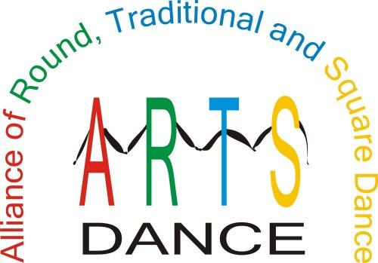

HOW YOUR DONATIONS WILL HELP

PROMOTE & PRESERVE OUR DANCE ACTIVITY

- PROVIDE EDUCATIONAL MATERIALS
- FUND MARKET RESEARCH
- DEVELOP AN ADVERTISING CAMPAIGN
- DEVELOP EDUCATIONAL PROGRAMS
- DEVELOP ADVERTISING MATERIALS
- PRESERVE HISTORICAL MATERIALS
- MATCHING FUNDS FOR GRANTS

THE ARTS Dance FOUNDATION is registered with the IRS as a 501(c)(3) corporation and all donations to the Foundation are tax deductible.

ARTS-DANCE ACCOMPLISHMENTS
PROMOTE & PRESERVE OUR
DANCE ACTIVITY
- Cooperation between national organizations to increase the number of dancers in the activity
- Surveys at several National Square Dance Conventions® to assist in market research
- Grant to the California Square Dance Council to create a notebook and CD for teachers to use in the schools to teach youth to square dance
- Toll-free number – 866-445-ARTS(2787)
- Magnetic signs with the toll-free number on them
- Travel website that donates a portion of the commissions to the ARTS
- Lapel pins
- What Is ARTS brochure and membership application
- Participation in the Education Program at the National Square Dance Convention®
- Table in the Showcase of Ideas at the National Square Dance Convention®

THE ARTS Dance FOUNDATION is registered with the IRS as a 501(c)(3) corporation and all donations to the Foundation are tax deductible.

PROMOTE & PRESERVE OUR DANCE ACTIVITY

ARTS-DANCE ACCOMPLISHMENTS

- Cooperation between national organizations to increase the number of dancers in the activity
- Grant to the California Square Dance Council to create a notebook and CD for teachers to use in the schools to teach youth to square dance
- Toll-free number – 866-445-ARTS(2787)
- Magnetic signs with the toll-free number on them
Add-A-Buck to your entrance fee and donate it
to the ARTS.
- Travel website that donates a portion of the commissions to the ARTS
- Lapel pins
- What Is ARTS brochure and membership application
- Participation in the Education Program at the National Square Dance Convention®
- Table in the Showcase of Ideas at the National Square Dance Convention®
HOW YOUR DONATIONS WILL HELP

- Provide educational materials
- Fund market research
- Develop an advertising campaign
- Develop educational programs
- Develop advertising materials
- Preserve historical materials
- Matching funds for grants

THE ARTS Dance FOUNDATION is registered with the IRS as a 501(c)(3) corporation and all donations to the Foundation are tax deductible.

ARTS-DANCE

Alliance of Round, Traditional and Square-Dance
The ARTS-Dance is an alliance of all the national square dance organiza-
tions gathering together with a goal of improving the dance activity and in-
creasing the number of dancers in our activity by 50,000 during the next 10
years.

Membership in ARTS-Dance is available to individuals and groups who
would like to participate and provide financial support to this worthwhile
effort.

One way to participate is to Add-A-Buck to your State Festival entrance
fee and donate it to ARTS-Dance.

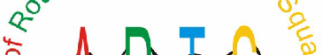

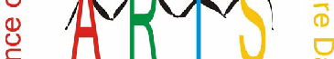
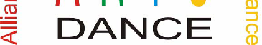

http://www.arts-dance.org

Donor Organization Treasurer Responsibilities

Treasurer responsibilities:

- Track Add-A-Buck donations separately from regular festival or dance fees.
- Provide tax receipt if donors wish to have one (multiple form provided for copying)
- Acknowledge the donation and announce it during your festival or dance
- Fill out Remittance Form
- Send one (1) check to the ARTS Treasurer for the total of all donations.

This note serves as your receipt for tax purposes related to the calendar year ___________.  The ARTS-DANCE FOUNDATION certifies no goods or services were granted in connection with this contribution of $______________.  Date __________________________________ | This note serves as your receipt for tax purposes related to the calendar year __________.  The ARTS-DANCE FOUNDATION certifies no goods or services were granted in connection with this contribution of $_____________.  Date __________________________________
This note serves as your receipt for tax purposes related to the calendar year ___________.  The ARTS-DANCE FOUNDATION certifies no goods or services were granted in connection with this contribution of $______________.  Date __________________________________ | This note serves as your receipt for tax purposes related to the calendar year __________.  The ARTS-DANCE FOUNDATION certifies no goods or services were granted in connection with this contribution of $_____________.  Date __________________________________
This note serves as your receipt for tax purposes related to the calendar year ___________.  The ARTS-DANCE FOUNDATION certifies no goods or services were granted in connection with this contribution of $______________.  Date __________________________________ | This note serves as your receipt for tax purposes related to the calendar year __________.  The ARTS-DANCE FOUNDATION certifies no goods or services were granted in connection with this contribution of $_____________.  Date __________________________________
This note serves as your receipt for tax purposes related to the calendar year ___________.  The ARTS-DANCE FOUNDATION certifies no goods or services were granted in connection with this contribution of $______________.  Date __________________________________ | This note serves as your receipt for tax purposes related to the calendar year __________.  The ARTS-DANCE FOUNDATION certifies no goods or services were granted in connection with this contribution of $_____________.  Date __________________________________
This note serves as your receipt for tax purposes related to the calendar year ___________.  The ARTS-DANCE FOUNDATION certifies no goods or services were granted in connection with this contribution of $______________.  Date __________________________________ | This note serves as your receipt for tax purposes related to the calendar year __________.  The ARTS-DANCE FOUNDATION certifies no goods or services were granted in connection with this contribution of $_____________.  Date __________________________________

ADD-A-BUCK DONATION REMITTANCE FORM

DATE” _________________________________

NAME OF DANCE:________________________________________________

If you wish, you may list individuals who donate MORE than $1 or just the total number of donors and total amount.
Name | Amount donated
Totals

Name of Organization & contact information:
Organization Name:
Street Address:
City: | State (Providence) | Zip
Contact Name: | Contact Phone:
Contact E-mail:

PLEASE MAKE AND KEEP A COPY FOR YOUR RECORDS
Return this form and your donations to:
ARTS Dance Foundation

Treasurer, Edythe Weber
1316 Middlebrook Dr
Liberty, MO 64068-1941

